Cit Pecyn Ymarfer a Gweithgareddau (De) Uned 8
Practice and Activity Pack (South Wales) Unit 8

A. Mae hi’n... Cofiwch y treiglad! Remember the mutation!

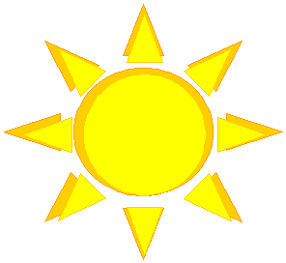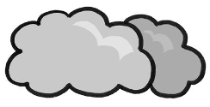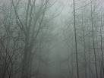

stormus ____________ ___________ _________ ______

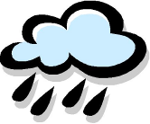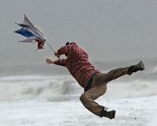

__________ ________ ________ ________ ________ ____________

B. Llenwch y bylchau

______ _________ tywydd heddiw?
______ _______ braf? ______. ______ _______ braf.

______ _______ bwrw eira?
_____ ______. ______ ____ ________ ____ bwrw eira. 

C. Atebwch

Be’ dach chi’n hoffi wneud pan mae’n braf?

________________________________________________________________________

Be’ dach chi’n hoffi wneud pan mae’n bwrw eira?

________________________________________________________________________

Be’ dach chi ddim yn hoffi wneud pan mae’n boeth?

________________________________________________________________________

Be’ dach chi ddim yn hoffi wneud pan mae’n bwrw glaw?

________________________________________________________________________

Ch. Treigladau Mutations

Brechdan → Ga’i __rechdan?
Dŵr → Ga’i ____ŵr?
Gwin coch → Ga’i __win coch?

Efo’ch plentyn

1. Slapio’r cerdyn Slap the card
- This game is suitable for younger children, who may not be ready for the activities in Uned 12 in the coursebook. It can, however, get quite exciting and boisterous!
- You will need the weather cards from the course card pack. Spread them out on the table top, on the floor, or stick them on the walls, avoiding any furniture/articles likely to cause an accident. The further apart you spread the cards, the more heated the game will get.
- If playing on the table top, all players must start with their hands on their head each time. If playing on the floor/walls, designate a ‘start position’ in the middle of the room.
- All players ask together Sut mae’r tywydd? One player calls Mae’n [braf]! The others have to run to the right card and slap it. The first person to reach it gets to call the next time.

2. Ble mae hi’n bwrw glaw?
- This game is a good way to familiarise your children with the names of Wales’s main cities and towns, and to help them to recognise these, and weather vocabulary, in print (your child may have started noticing weather words on a poster in the nursery or school). Even if your child is not old enough to read, the activity has value as it gets him/her used to the idea of reading as part of playing a game. Many children will be perfectly happy to guess randomly until they get the right answer.
- Put the following cards from the pack in a pile, face down: bwrw glaw, oer, gwyntog, heulog, twym/poeth, cymylog, niwlog, bwrw eira.
- Take a card, and ask Sut mae’r tywydd? When the right answer is given, ask Lle mae hi’n [bwrw glaw]? and point at the map, encouraging your child to work it out or guess. You may need to prompt by saying the place names aloud. Accept one-word answers, i.e. Caerdydd. Respond with Ia. Da iawn ti!/Naci. Dim [Aberystwyth]. Trïa/Trïwch eto (try again). The card is put in position on the page.

Llandrindod
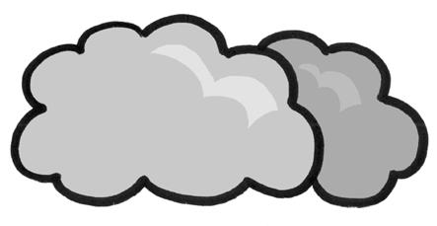
Caernarfon
Llandudno


Aberystwyth
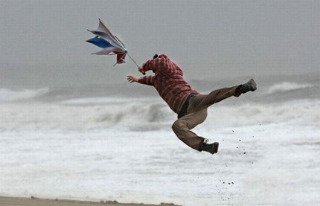
Caerfyrddin
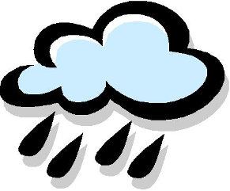
Abertawe
Casnewydd
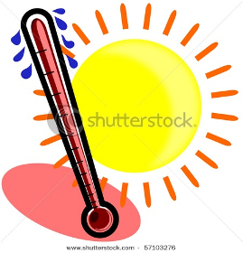
Caerdydd
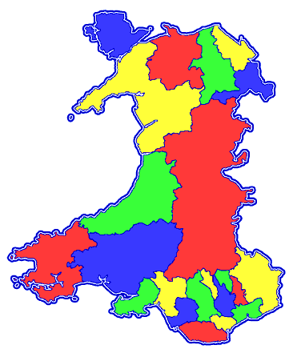
Cards to cut out for the above game

 |  | 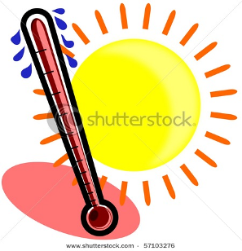
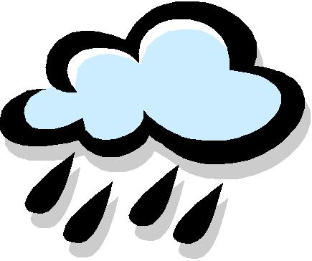 | 

